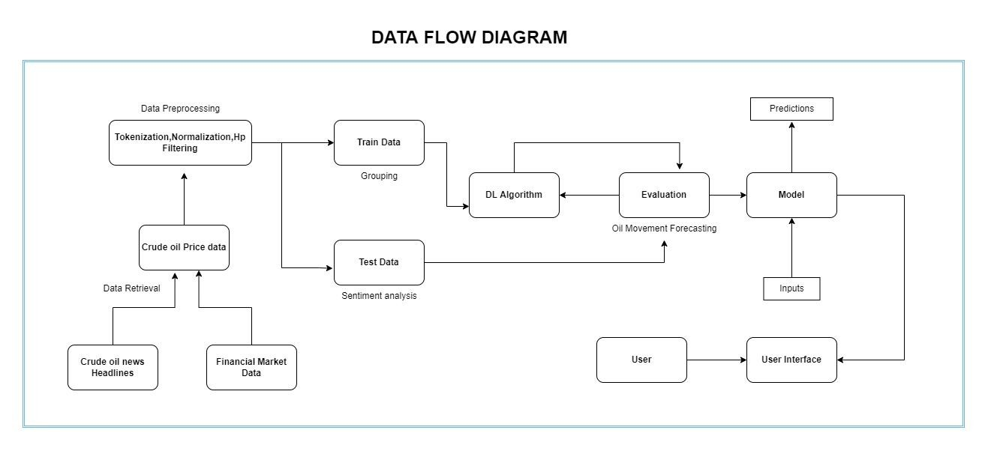

# Project Design Phase-II

**Data Flow Diagram & User Stories**

|  |  |
| --- | --- |
| Date | 03 October 2022 |
| Team ID | PNT2022TMID15696 |
| Project Name | Project - Crude Oil Price Prediction |
|  |  |

## Data Flow Diagrams:

A Data Flow Diagram (DFD) is a traditional visual representation of the information flows within a system. A neat and clear DFD can depict the right amount of the system requirement graphically. It shows how data enters and leaves the system, what changes the information, and where data is stored.

## User Stories

Use the below template to list all the user stories for the product.

|  |  |  |  |  |  |  |
| --- | --- | --- | --- | --- | --- | --- |
| **User Type** | **Functional**  **Requirement (Epic)** | **User Story**  **Number** | **User Story/ Task** | **Acceptance criteria** | **Priority** | **Release** |
| Customer (Mobile User) | Registration | USN-1 | As a user,I can register for the application by entering my email, password,and confirming  my password. | I can access my account/ Displays Line gragh / Bar gragh. | High | Sprint-1 |
|  |  | USN-2 | As a user,I will receive confirmation email once I have registered for the application | I can receive confirmation email & click confirm | High | Sprint-1 |
|  |  | USN-3 | As a user,I can register for the application through Facebook | I can register & accessthe my Account | Low | Sprint-2 |
|  |  | USN-4 | As a user,I can register for the application  through Gmail | I can register through already logged in gmail account. | Medium | Sprint-1 |
|  | Login | USN-5 | As a user,I can log into the application by entering email & password | After registration,I can log in by only email & password. | High | Sprint-1 |
|  | Line\Bar gragh |  | After entering the inputs,the model will display predictions in Line\Bar Gragh Format. | I can get the expected prediction in various formats. | High | Sprint-3 |
| Customer (Web user) | Login | USN-1 | As the web user,I can login simply by using Gmail or Facebook account. | Already created gmail can be used for Login. | Medium | Sprint-2 |
| Customer Care Executive | Support |  | The Customer care service will provide solutions for any FAQ and also provide ChatBot. | I can solve the problems arised by Support. | Low | Sprint-3 |
| Administrator | News |  | Admin will give the recent news of Oil Prices. | Provide the recent oil prices. | High | Sprint-4 |
|  | Notification |  | Admin will notify when the oil prices changes. | Notification by Gmail. | High | Sprint-4 |
|  | Access Control |  | Admin can control the access of users. | Access permission for Users. | High | Sprint-4 |
|  | Database |  | Admin can store the details of users. | Stores User details. | High | Sprint-4 |